 **Assignment Cover Sheet**

|  |  |  |
| --- | --- | --- |
| **Student Information (For group assignment, please state names of all members)** | | **Grade/Marks** |
| KENJI YANG QI YUAN | **B1900717** |  |
| MUHAMMAD SIDDIQ | **B1901633** |  |
| MUNAVAR SHAFIQ | **B1901504** |  |

|  |  |  |
| --- | --- | --- |
| **Module/Subject Information** | | **Office Acknowledgement** |
| Module/Subject Code | BIT 201 |  |
| Module/Subject Name | WEB PROGRAMMING |  |
| Lecturer/Tutor/Facilitator | DR. ABDUL QAYOOM HAMAL |  |
| Due Date | 23 OCT 2020 |  |
| Assignment Title/Topic | Assignment 1 |  |
| Intake (where applicable) | AUGUST |  |
| Word Count | n/a | **Date/Time** |

**Declaration**

* I/We have read and understood the Programme Handbook that explains on **plagiarism**, and I/we testify that, unless otherwise acknowledged, the work submitted herein is entirely my/our own.
* I/We declare that no part of this assignment has been written for me/us by any other person(s) except where such collaboration has been authorized by the lecturer concerned.
* I/We authorize the University to test any work submitted by me/us, using text comparison software, for instances of plagiarism. I/We understand this will involve the University or its contractors copying my/our work and storing it on a database to be used in future to test work submitted by others.

Note: 1) The attachment of this statement on any electronically submitted assignments will be deemed to have the same authority as a signed statement.

2) The Group Leader signs the declaration on behalf of all members.

|  |  |
| --- | --- |
| Signature: KENJI | Date: 23/10/2020 |
| E-mail: kenji_yang3@hotmail.com |  |

|  |
| --- |
| **Feedback/Comments\*** |
| **Main Strengths** |
|  |
|  |
|  |
|  |
|  |
|  |
| **Main Weaknesses** |
|  |
|  |
|  |
|  |
|  |
|  |
|  |
| **Suggestions for improvement** |
|  |
|  |
|  |
|  |
|  |
|  |

|  |  |
| --- | --- |
|  | **Student acknowledge feedback/comments** |
|  |
| Grader’s signature | Student’s signature: |
| Date: | Date: |

Note:

1. A soft and hard copy of the assignment shall be submitted.
2. The signed copy of the assignment cover sheet shall be retained by the marker.
3. If the Turnitin report is required, students have to submit it with the assignment. However, departments may allow students up to **THREE** (3) working days after submission of the assignment to submit the Turnitin report. The assignment shall only be marked upon the submission of the Turnitin report.

CTIS WEBSITE SYSTEM

Github: <https://kenjiyang03.github.io/>

B1900717 KENJI YANG QI YUAN

B1901633 MUHAMMAD SIDDIQ

B1901504 MUNAVAR SHAFIQ

HELP University

**CONTENTS**

**1**  **TASK 1_ PROJECT TITLE 3**

**2**  **TASK 2_ USE CASE / TASK DISTRIBUTION 5**

**3**  **TASK 3_ MANUAL GUIDE 6**

**4 TASK 4_SCREENSHOT OF WEBPAGES**   **6**

**5 TASK 5_ SNIPPET OF CODE FOR USE CASES**  **12**

**6 TASK 6_ THREE CHALLENGES THAT WE FACED**   **18**

**7 TASK 7_ WEB DEVELOPMENT FRAMEWORK AND TECHNOLOGY 19**

**8 TASK 8_ REFERENCES**  **20**

TASK 2 USE CASE / TASK DISTRIBUTION

Kenji Yang B1900717

Use Case 1: Register Test Centre – login page and registration page were made to able user to register test centre.

Use Case 2: Record Test Centre Officer – officer registration page was made to able user to record info of the officer

Use Case 3: Manage Test Kit Stock – stock page was made to able user to record down the amount test kit left.

Muhammad Siddiq

Use case 1: Test results- This page is where the patients can view their results.

Use case 2: Covid-19 Statistics- Here in this page, the public can keep up to date with the latest covid-19 numbers.

Use case 3: Health resources: This page provides a general whereabouts of local and nearby health facilities, as well as helpful ways to prevent the spread of covid-19.

Munavar Shafiq

Use Case 1:Record New Test-This page is where Tester records patient details.

Use Case 2:Update Test Result-This page is for tester to update the results of a test.

Use Case 3:View Testing History – This page is for the tester to view patients test info from the centre he is assigned.

TASK 3 MANUAL GUIDE/TASK 4 SCREENSHOT OF WEBPAGES

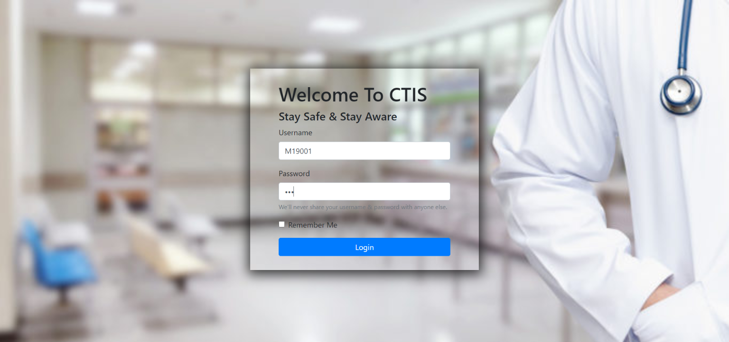

(Diagram above (a) login page)

Here user will login, either as a tester, officer, manager, or patient.

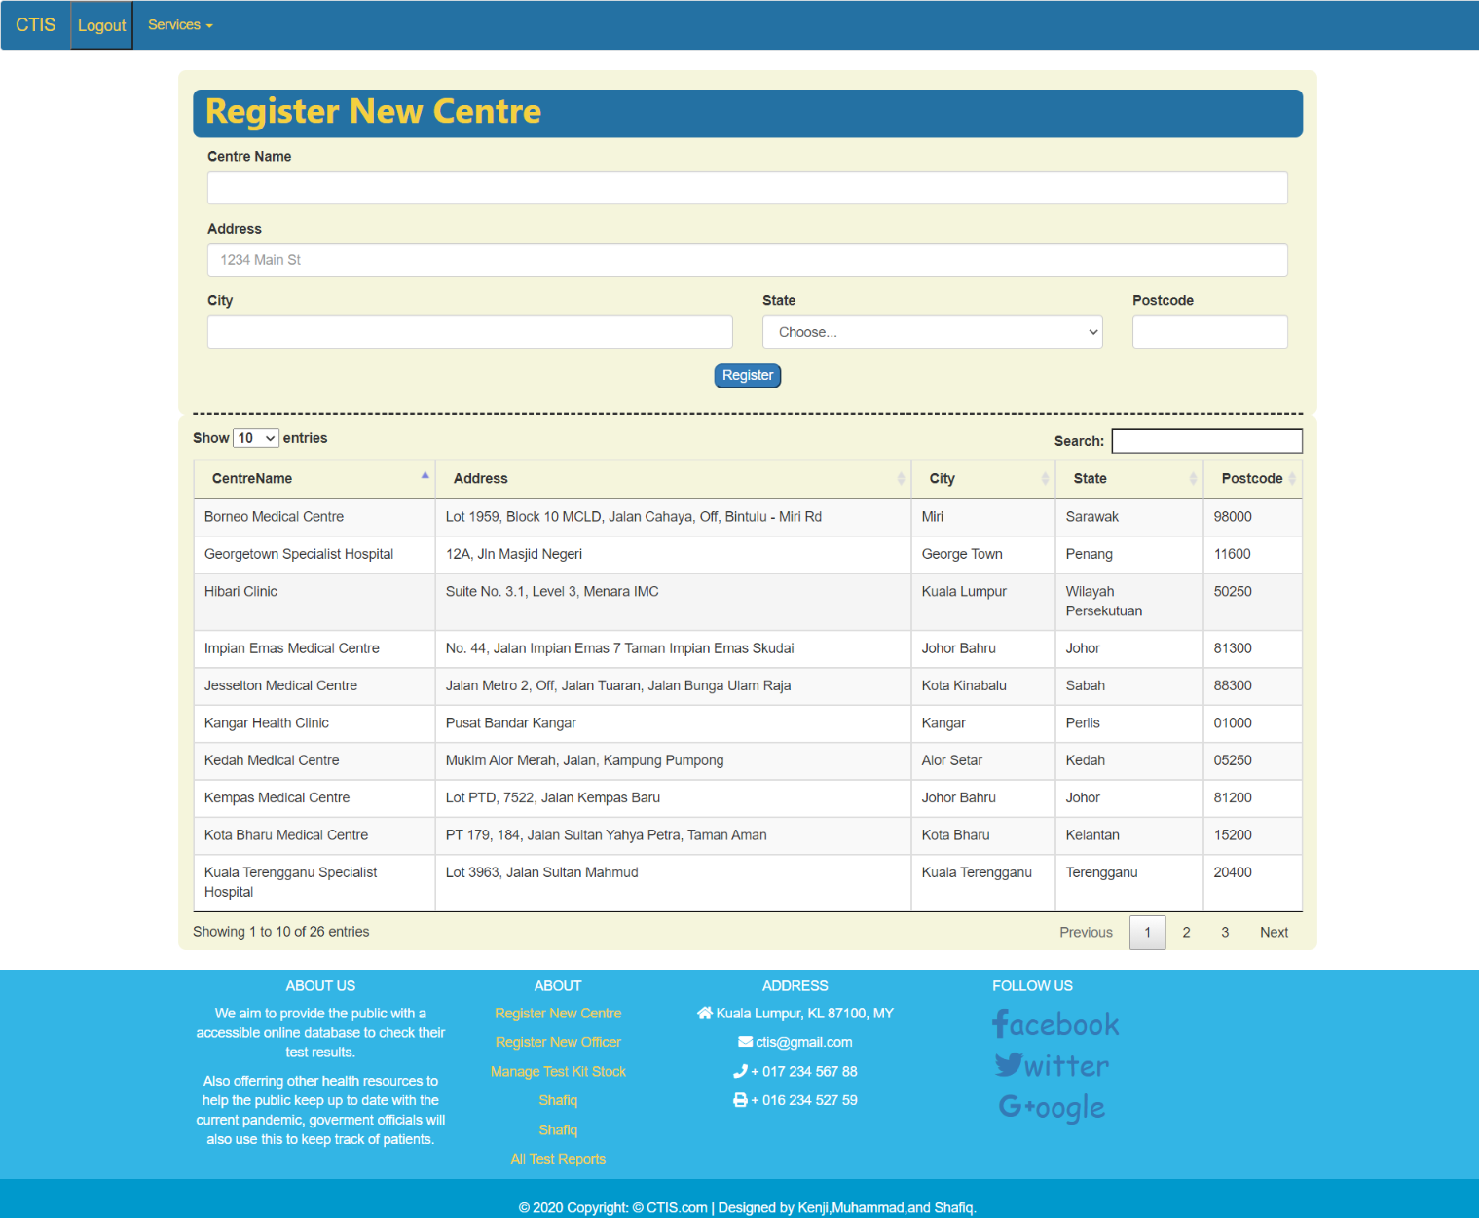

(Diagram above (b) centre registration page)

On this page the manager will register the test center.

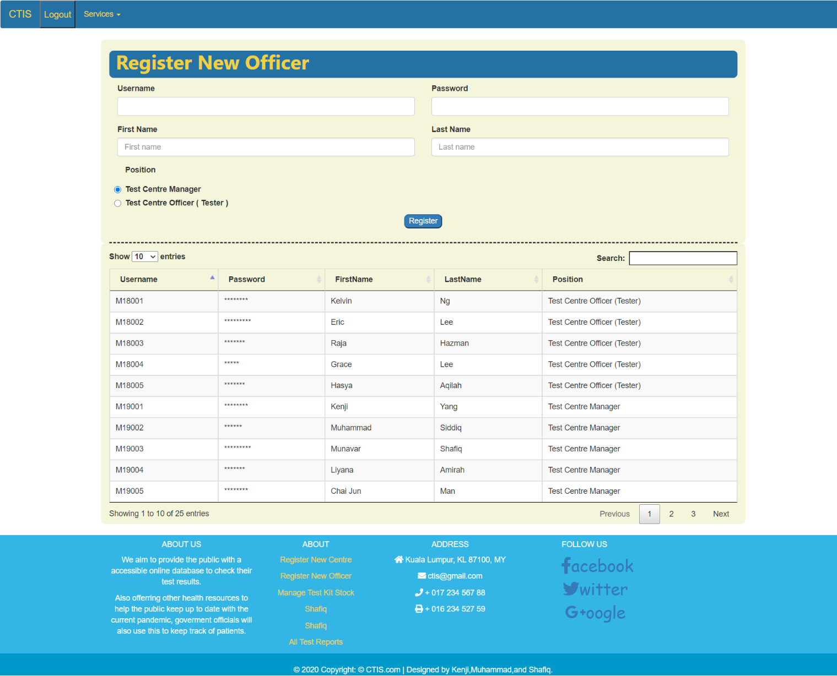

(Diagram above (c) officer registration page)

On this page, this is where the officers will register their details.

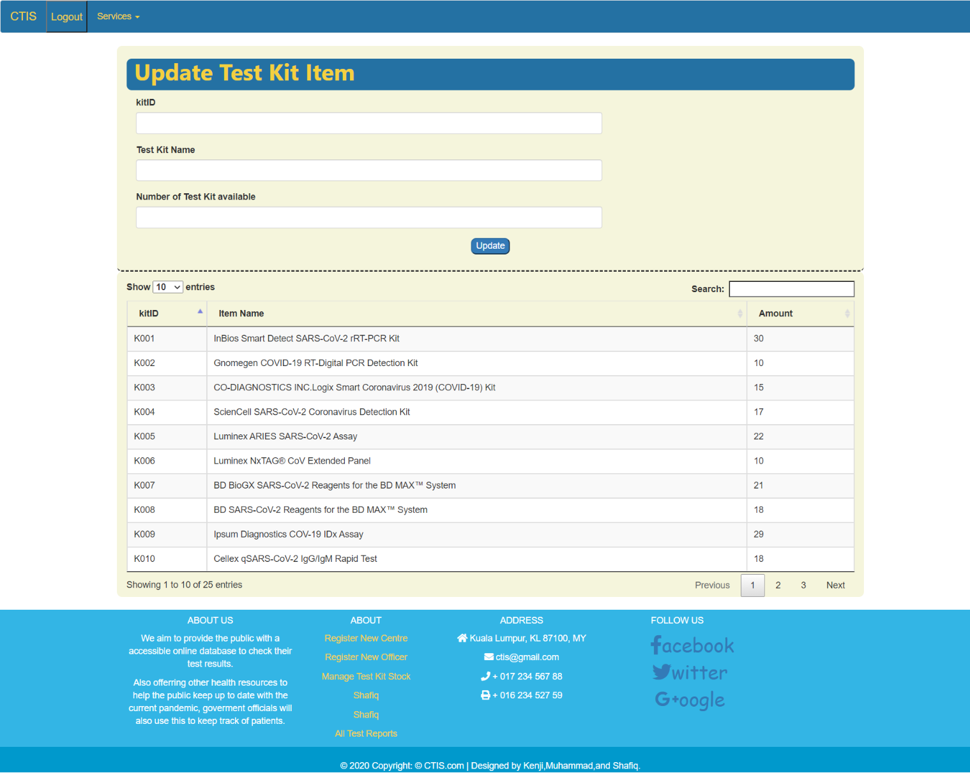

(Diagram above (d) stock page)

On this page, the manager will update the stock kit numbers

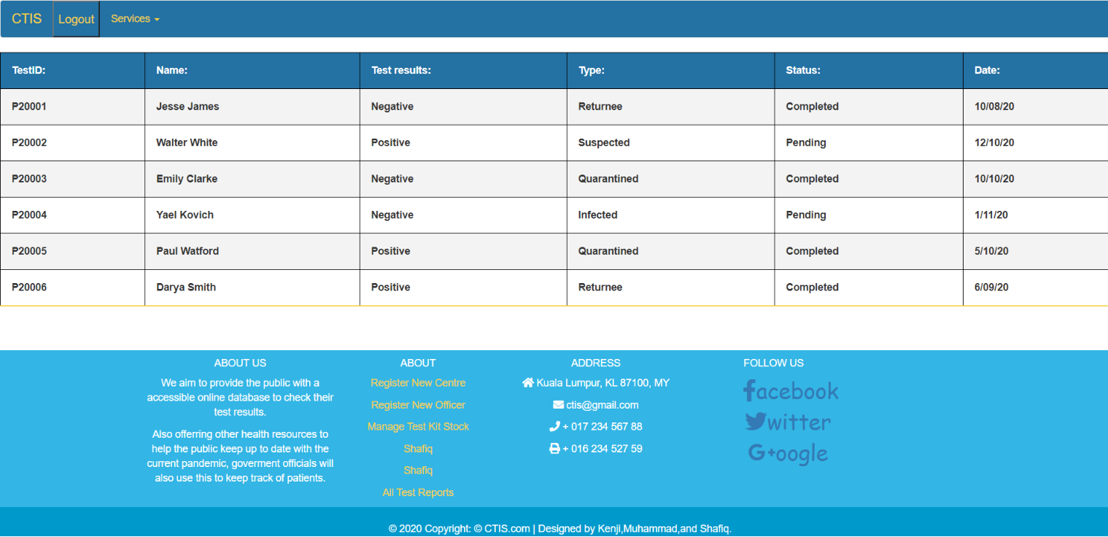

(Diagram above (e) all test report page)

In this page patients can view their results

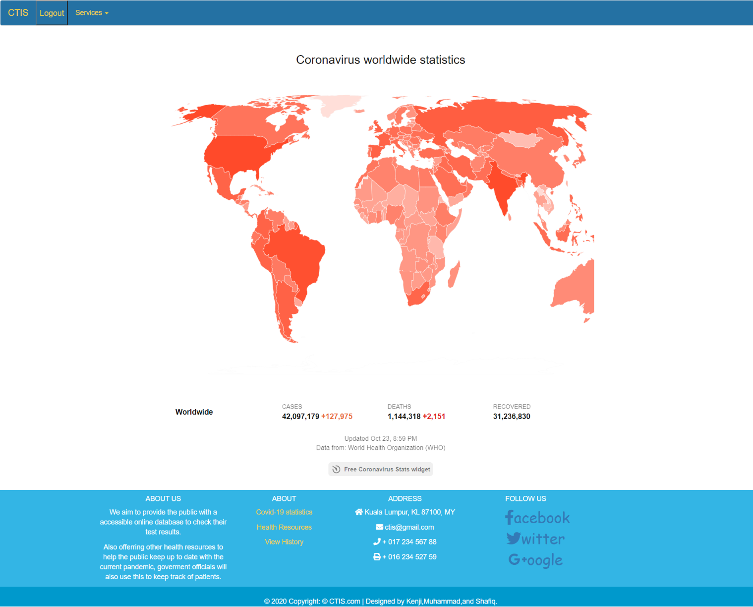

(Diagram above (f) covid stats page)

In this page the general public can keep up to date with the latest number of cases each day

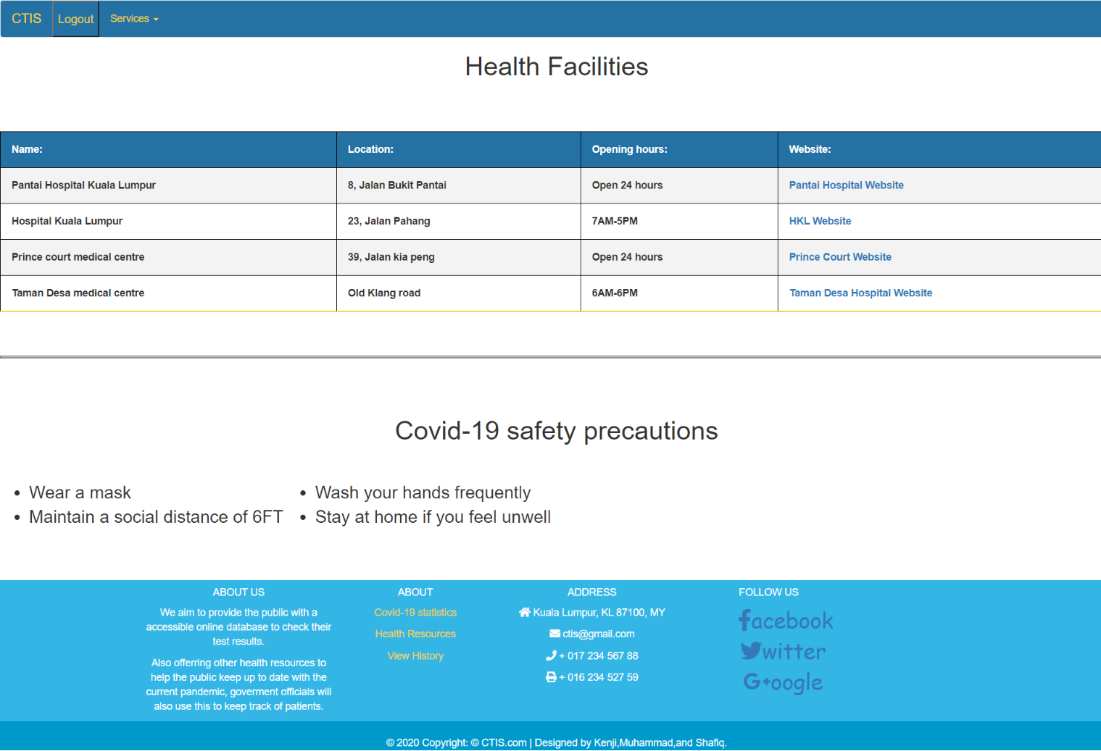

(Diagram above (g) health resources page)

In this page, it is just general information on how to prevent the spread of covid-19

And locations of nearby health facilities

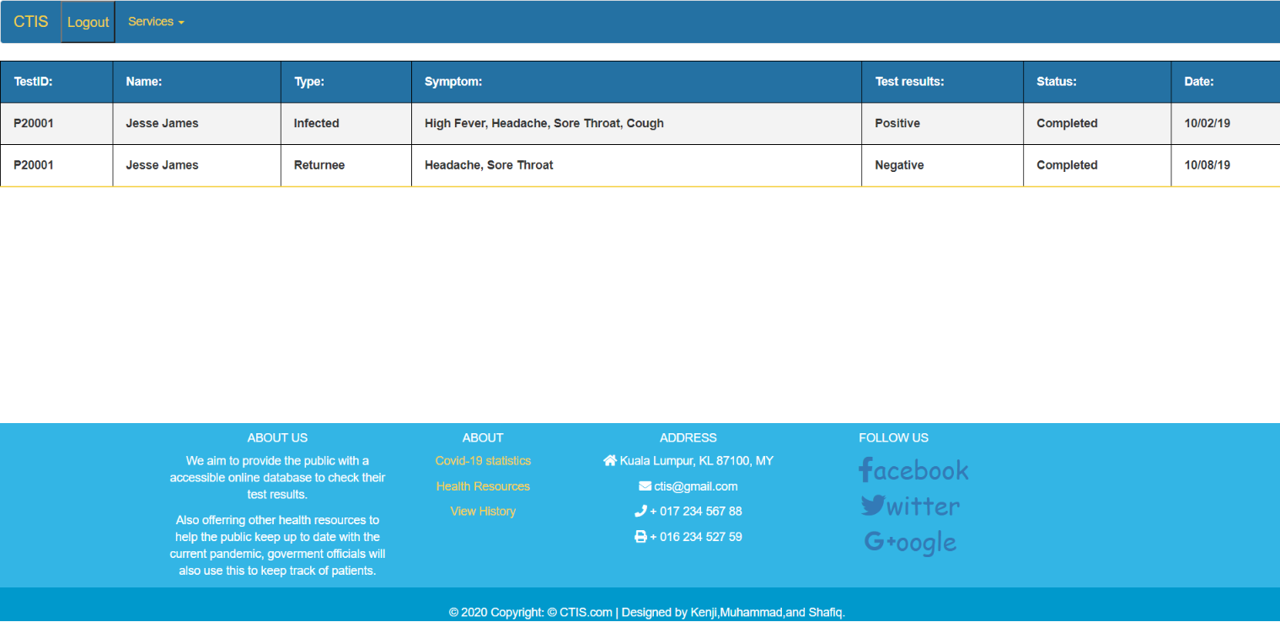

(Diagram above (h) testing history page)

This is the page where a patient can view his/her test results and it will be monitored

If any changes were to be made

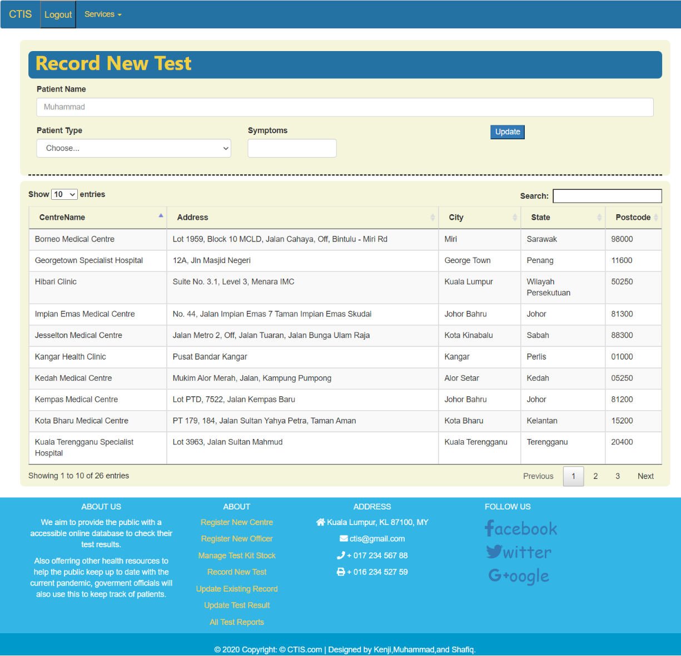

(Diagram above (i) Record new Test page)

Here in this page, the testers will record the new results from the patients

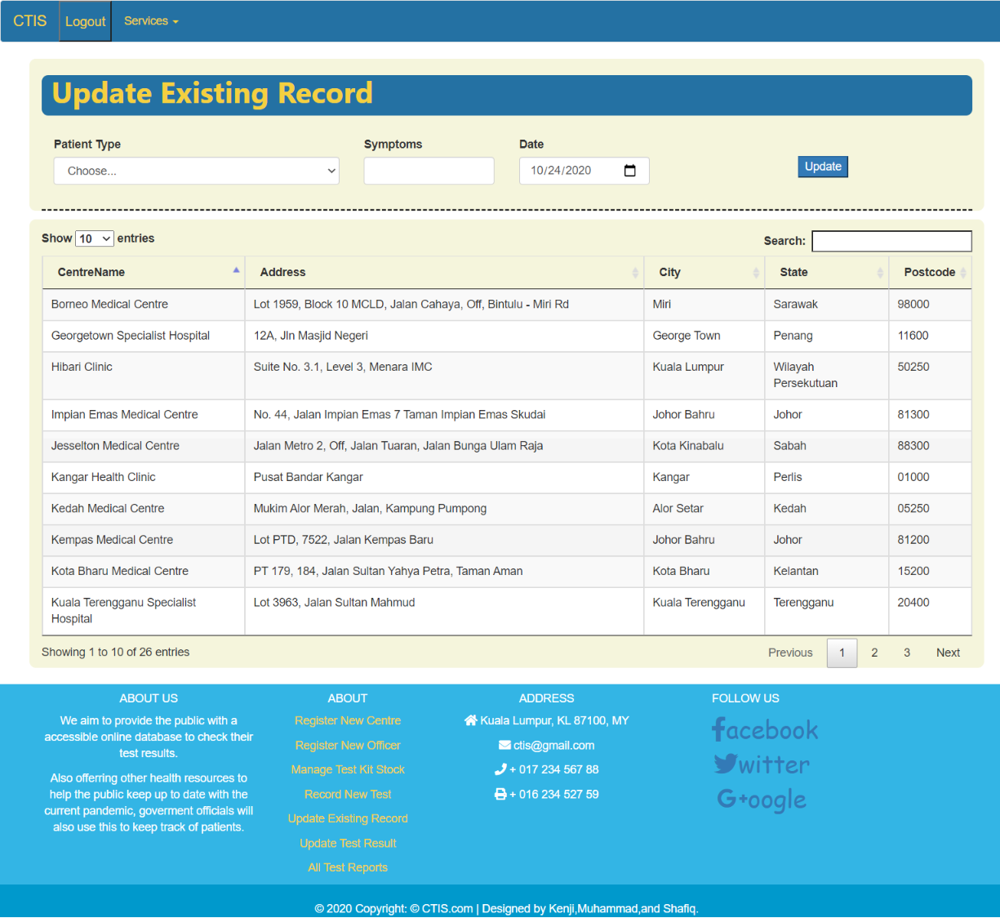

(Diagram above (j) Update existing record page)

In this page the tester will be able to update the existing record that already available in the system

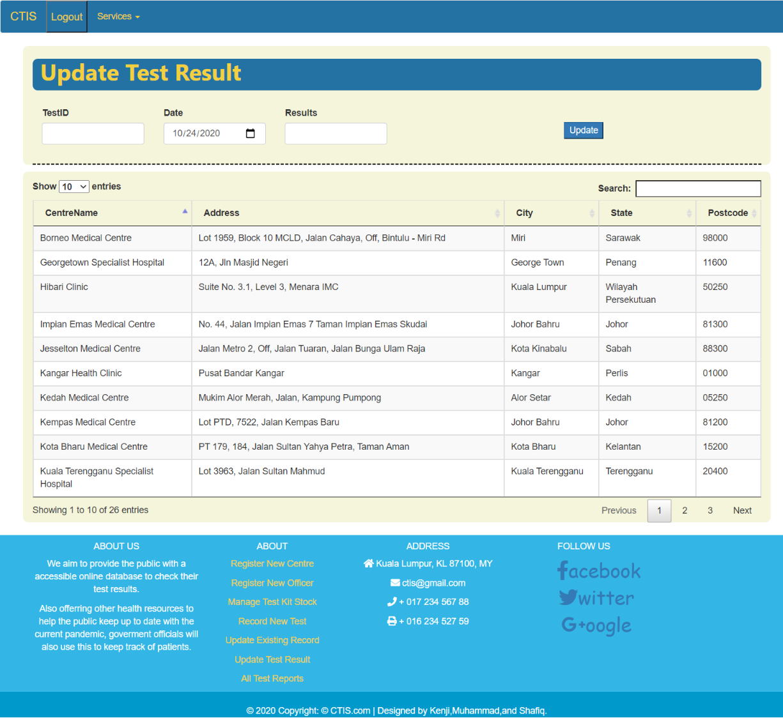

(Diagram above (k) update test result page)

Here in this page the tester can update the already inputted data,

If any of the data needs to be updated in the following weeks

TASK 5 SNIPPET OF CODES FOR USE CASES

Use case: testsReports.html

<table class="PVH" style="width: 100%;">

<tr>

<th>Name:</th>

<th>Test results:</th>

<th>Type:</th>

<th>Status:</th>

<th>Date:</th>

</tr>

<tr>

<th>Jesse James</th>

<th>Negative</th>

<th>Returnee</th>

<th>Completed</th>

<th>10/08/20</th>

</tr>

<tr>

<th>Walter White</th>

<th>Positive</th>

<th>Suspected</th>

<th>Pending</th>

<th>12/10/20</th>

</tr>

Use case: CovidStats.html

<!--Live covid-19 update widget-->

<script src="https://apps.elfsight.com/p/platform.js" defer></script>

<div class="elfsight-app-0ed544b1-75a7-4d0c-83e2-4bd2f34959a8"></div>

Use case: LocateHealthFacilites.html

<table class="HS" style="width: 100%;">

<tr>

<th>Name:</th>

<th>Location:</th>

<th>Opening hours:</th>

<th>Website:</th>

</tr>

<tr>

<th>Pantai Hospital Kuala Lumpur</th>

<th>8, Jalan Bukit Pantai</th>

<th>Open 24 hours</th>

<th><a href="https://www.pantai.com.my/kuala-lumpur">Pantai Hospital Website</a></th>

</tr>

<tr>

<th>Hospital Kuala Lumpur</th>

<th>23, Jalan Pahang</th>

<th>7AM-5PM</th>

<th><a href="http://www.hkl.gov.my/">HKL Website</a></th>

</tr>

KENJI YANG B1900717

USE CASE 1: REGISTER TEST CENTRE

<form id="registerBtn1" class="form-centre">

<div class="form-group col-md-12">

<label for="inputCentreName">Centre Name</label>

<input type="text" class="form-control" id="inputCentreName" required="">

</div>

<div class="form-group col-md-12">

<label for="inputAddress">Address</label>

<input type="text" class="form-control" id="inputAddress" placeholder="1234 Main St" required="">

</div>

<div class="form-row">

<div class="form-group col-md-6">

<label for="inputCity">City</label>

<input type="text" class="form-control" id="inputCity" required="">

</div>

</div>

<div class="form-group col-md-4">

<label for="inputState">State</label>

<select id="inputState" class="form-control">

<option selected>Choose...</option>

<option>Sabah</option>

<option>Sarawak</option>

<option>Selangor</option>

<option>Penang</option>

<option>Perak</option>

<option>Perlis</option>

<option>Wilayah Persekutuan</option>

<option>Pahang</option>

<option>Kedah</option>

<option>Kelantan</option>

<option>Terengganu</option>

<option>Melaka</option>

<option>Johor</option>

<option>Negeri Sembilan</option>

</select>

</div>

<div class="form-group col-md-2">

<label for="inputPostcode">Postcode</label>

<input type="text" class="form-control" id="inputPostcode" required="">

</div>

<div class="form-group">

<div class="row">

<div class="col text-center">

<button class="btn1 btn-primary">Register</button>

</div>

</div>

</div>

</form>

USE CASE 2: RECORD TEST CENTRE OFFICER

<form id="registerBtn2" class="form-centre">

<div class="form-row">

<div class="form-group col-md-6">

<label for="inputUsername">Username</label>

<input type="text" class="form-control" id="inputUsername" required="">

</div>

<div class="form-group col-md-6">

<label for="inputPassword4">Password</label>

<input type="password" class="form-control" id="inputPassword4" required="">

</div>

</div>

<div class="form-row">

<div class="form-group col-md-6">

<label for="inputfName">First Name</label>

<input type="text" class="form-control" placeholder="First name" required="">

</div>

<div class="form-group col-md-6">

<label for="inputlName">Last Name</label>

<input type="text" class="form-control" placeholder="Last name" required="">

</div>

</div>

<div class="form-row">

<div class="form-group-radio col-md-12">

<label>Position</label>

<label class="radio active">

<input type="radio" name="options" id="option1" autocomplete="off" checked> Test Centre Manager

</label>

<label class="radio">

<input type="radio" name="options" id="option2" autocomplete="off"> Test Centre Officer ( Tester )

</label>

</div>

</div>

<div class="form-group">

<div class="row">

<div class="col text-center">

<button class="btn1 btn-primary">Register</button>

</div>

</div>

</div>

</form>

USE CASES 3: Manage Test Kit Stock

<form id="registerBtn3">

<div class="form-group col-md-8">

<label for="itemID">kitID</label>

<input type="text" class="form-control" id="itemID" required="">

</div>

<div class="form-group col-md-8">

<label for="itemName">Test Kit Name</label>

<input type="text" class="form-control" id="itemName" required="">

</div>

<div class="form-group col-md-8">

<label for="amountItem">Number of Test Kit available</label>

<input type="text" class="form-control" id="amountItem" required="">

</div>

<div class="form-group col-md-12 text-center">

<button class="btn1 btn-primary">Update</button>

</div>

</form>

<div class="container form-registration mb-3 mt-3" style="padding-top:1em;">

<table id="stockDatatable" class="table table-striped table-bordered" style="width:100%"></table>

</div>

B1901504 MUNAVAR SHAFIQ

Use Case 1

<form id="registerBtn1" class="form-centre">

<div class="form-group col-md-12">

<label for="inputname">Patient Name</label>

<input type="text" class="form-control" id="inputPatientName" placeholder="Muhammad" required="">

</div>

<div class="form-group col-md-4">

<label for="inputPatienttype">Patient Type</label>

<select id="inputPatienttype" class="form-control">

<option selected>Choose...</option>

<option>Returnee</option>

<option>Quarantined</option>

<option>Close Contact</option>

<option>Infected</option>

<option>Suspected</option>

</select>

</div>

<div class="form-group col-md-2">

<label for="inputSymptoms">Symptoms</label>

<input type="text" class="form-control" id="inputSymptoms" required="">

</div>

<div class="form-group">

<div class="row">

<div class="col text-center">

<button class="btn2 btn-primary" onclick="myFunction()">Update</button>

</div>

</div>

</div>

</form>

<form id="UpdateBtn1" class="form-centre">

<div class="form-group col-md-12">

</div>

<div class="form-group col-md-4">

<label for="inputPatienttype">Patient Type</label>

<select id="inputPatienttype" class="form-control">

<option selected>Choose...</option>

<option>Returnee</option>

<option>Quarantined</option>

<option>Close Contact</option>

<option>Infected</option>

<option>Suspected</option>

</select>

</div>

<div class="form-group col-md-2">

<label for="inputSymptoms">Symptoms</label>

<input type="text" class="form-control" id="inputSymptoms" required="">

</div>

<div class="form-group col-md-2">

<label for="inputDate">Date</label>

<input type="date" class="form-control" id="inputDate" required=""

value="2020-10-24"

min="2020-01-01" max="2022-12-01">

</div>

<br><br>

<div class="form-group">

<div class="row">

<div class="col text-center">

<button class="btn2 btn-primary" onclick="myFunction()">Update</button>

</div>

</div>

</div>

</form>

Use Case 2:

<form id="UpdateBtn1" class="form-centre">

<div class="form-group col-md-12">

</div>

<div class="form-group col-md-2">

<label for="inputTestID">TestID</label>

<input type="text" class="form-control" id="inputTestID" required="">

</div>

<div class="form-group col-md-2">

<label for="inputDate">Date</label>

<input type="date" class="form-control" id="inputDate" required=""

value="2020-10-24"

min="2020-01-01" max="2022-12-01">

</div>

<div class="form-group col-md-2">

<label for="inputResults">Results</label>

<input type="text" class="form-control" id="inputResults" required="">

</div>

<br><br>

<div class="form-group">

<div class="row">

<div class="col text-center">

<button class="btn2 btn-primary" onclick="myFunction()">Update</button>

</div>

</div>

</div>

</form>

Use Case 3

<table class="PVH" style="width: 100%;">

<tr>

<th>TestID:</th>

<th>Name:</th>

<th>Test results:</th>

<th>Status:</th>

<th>Date:</th>

</tr>

<tr>

<th>P19001</th>

<th>Jesse James</th>

<th>Negative</th>

<th>Completed</th>

<th>10/08/20</th>

</tr>

</table>

TASK 6 : THREE CHALLENGES THAT WE FACE DURING DEVELOPMENT

Kenji Yang B1900717

1) One of the challenges that we face while in the development phase was that we are unable to create a fully functional page that could be update and edit from the form to the table listed below. Thus, we manage to make a form where it receives the input and confirms with the user and a fake data below to show the data being listed down below. Not just that, we also have hard time figuring out how to join 2 different webpages for 1 login pages but we manage to figure out at last by using java script to make with if else statement.

Muhammad Siddiq:

2) One of the challenges for me was create the logout button on the top of the navigation bar, the function required it to be pressed, and once pressed a confirm pop-up will appear and two option will be provided, either “ok” or “cancel”, if the user clicks ok it will redirect the user back to the register page and successfully logout, or if the user clicks on cancel, then an alert will pop up saying that user has pressed cancel and the user will remain on the same page. The hardest part was finding a way to redirect the user when he/she clicked okay because the it was not a link but a button, so I had to find a method in which to add the href of the register page, so I used the location.href method in the if-else method.

Munavar Shafiq B1901504:

3) One of the challenges for me was javascript. We had to use javascript to map buttons and add events. At first it was confusing but slowly with the help of my teammates I was able to overcome it. Other than that the design language of the page was challenging too.Since we cant have a face to face meeting we had to keep receiving the updates from teammates to the design of the page. In order to standardize the pages user experience.

TASK 7: WEB DEVELOPMENT FRAMEWORK AND TECHNOLOGIES USED IN WED DEVELOPMENT PROJECT

One of the web development frameworks we used in our project is Bootstrap4. Bootstrap is very useful as it is a collection of a few tools such as HTML, CSS and JavaScript. In bootstrap, we can make our design more responsive thus it is much more flexible for use as developers. Not just that, developers get to enjoy more customization and changes by using bootstraps. Bootstraps also comes with source code version which simplified the complex task of the developers and makes coding much simpler. Besides that,we are still able to use pluggins which as jquery or javascript extension to provide more interactive website than just a simple design page with no function provided. Bootstraps uses name with meaning which can be overidden with CSS style and color and also the components such as semantic class names can be reuse.

Another one of the web development framework software we used was jQuery. JQuery is a fast, small, rich javascript library that allows the manipulation of event handlers, animations and much more that is very easy to use and is supported by a multitude of browsers. We used jquery in most of our website layout to make it more responsive and suitable across multiple devices. We also used jquery to develop the pop-up boxes you see when yo interact with certain buttons.

TASK 8: REFERENCES

*What is Bootstrap? A Short Bootstrap Tutorial on the What, Why, and How*. (n.d.). <Https://Www.Toptal.Com/Front-End/What-Is-Bootstrap-a-Short-Tutorial-on-the-What-Why-and-How>. Retrieved October 23, 2020, from <https://www.toptal.com/front-end/what-is-bootstrap-a-short-tutorial-on-the-what-why-and-how>

JS Foundation - js.foundation. (n.d.). *jQuery*. <Https://Jquery.Com/#:~:Text=jQuery%20is%20a%20fast%2C%20small,Across%20a%20multitude%20of%20browsers>. Retrieved October 23, 2020, from <https://jquery.com/#:%7E:text=jQuery%20is%20a%20fast%2C%20small,across%20a%20multitude%20of%20browsers>.

|  |  |  |  |  |
| --- | --- | --- | --- | --- |
|  |  |  |  |  |
|  |  |  |  |  |
|  |  |  |  |  |
|  |  |  |  |  |

**Marking Criteria**

The following will be assessed:

|  |  |  |  |  |  |  |
| --- | --- | --- | --- | --- | --- | --- |
|  |  |  |  |  |  | **Marks** |
| **LO assessed** |  |  | **Topic** |  |  | **Awarded** |
|  |  |  |  |  |  |  |
| CLO2: Develop a client-server | **1.** | **Overall look of the finished product (20 marks)** |  |  |  |  |
| internet application that |  |  |  |  |  |  |
| accommodates specific |  |  |  |  |  |  |
|  |  |  |  |  |  |  |
| requirements and constraints | Level C - Little artistic merit, |  | Level B - Artistic flair and good | Level A - Well designed appealing |  |  |
|  |  |  |  |  |  |  |
|  | header image, footer floats |  | design look. Contents in the website | site with complete website |  |  |
|  | correctly under content, CSS menu |  | well arranged. (7-14) | requirements. (15-20) |  |  |
|  | correctly placed. (0-6) |  |  |  |  |  |
|  |  |  |  |  |  |  |
| CLO2: Develop a client-server | **2.** | **Appropriate use of HTML elements (15 marks)** – **Individual** |  |  |  |  |
| internet application that |  |  |  |  |  |  |
| accommodates specific |  |  |  |  |  |  |
|  |  |  |  |  |  |  |
| requirements and constraints |  |  | Level B – HTML tags and elements |  |  |  |
|  | Level C - Minimal and |  |  | Level A – As level B but extensive use |  |  |
|  | inappropriate usage of HTML |  | are incorporated properly with | of HTML elements. | HTML |  |
|  | tags and elements. (0-5) |  | heading, hyperlinks and lists. (6-10) | elements are included such | as |  |
|  |  |  |  | tables, image link, nested lists, forms, |  |  |
|  |  |  |  | etc. HTML elements are included |  |  |
|  |  |  |  | appropriately based on the required |  |  |
|  |  |  |  | functionalities. (11-15) |  |  |
|  |  |  |  |  |  |  |
| CLO2: Develop a client-server | **3.** | **Appropriate use of Bootstrap features (15 marks)** |  |  |  |  |
| internet application that |  |  |  |  |  |  |
| accommodates specific |  |  |  |  |  |  |
| requirements and constraints |  |  |  |  |  |  |
|  | Level C– Minimal and |  | Level B – Bootstrap are incorporated | Level A – Complete application of |  |  |
|  | inappropriate usage of Bootstrap |  | properly with most of the web element | Bootstrap to produce responsive |  |  |
|  | features. (0-5) |  | displaying responsive features. (6-10) | features for all elements in the |  |  |
|  |  |  |  | webpages. (11-15) |  |  |
|  |  |  |  |  |  |  |

|  |  |  |  |  |  |  |
| --- | --- | --- | --- | --- | --- | --- |
| CLO2: Develop a client-server |  | **4.** | **Dynamic Web Functionalities with JavaScript (20 Marks) - Individual** |  |  |  |
| internet application that |  |  |  |  |  |  |
|  |  |  |  |  |  |  |
| accommodates specific |  |  |  |  |  |  |
| requirements and constraints |  |  |  |  |  |  |
|  | Level C – Developed some of the basic |  |  | Level B – Developed most of the | Level A – Developed all of the |  |
|  |  |  |  |  |  |  |
|  |  |  |  | elements and functionalities (use case) | elements and functionalities (use |  |
|  | elements and functionalities |  | (use case) |  |  |  |
|  |  |  |  | required in the case study. Use cases | case) required in the case study. Use |  |
|  | required in case study. Use cases are not |  |  |  |  |  |
|  |  |  |  | are distributed evenly among two | cases are distributed evenly among |  |
|  | distributed | evenly among the two |  |  |  |  |
|  |  |  |  | members. (7-14) | two members. Appropriate |  |
|  | members. | (0-6) |  |  | comments on sections of code. (15- |  |
|  |  |  |  |  | 20) |  |
|  |  |  |  |  |  |  |

|  |  |  |  |  |  |  |  |
| --- | --- | --- | --- | --- | --- | --- | --- |
| CLO3: Work in a team to | **5.** | **Presentation (15 marks)** – **Individual** |  |  |  |  |  |
|  |  |  |  |  |  |  |  |
|  |  |  |  |  |  |  |  |
| propose interactive web | Level C – Mininal understanding of the |  | Level B –. Good understanding of | Level A – Thorough understanding of |  |  |  |
| applications with regard to | different elements used that include |  | different elements used together | different elements used together with |  |  |  |
|  | layout, styling, dynamic web content etc. |  | with the implementation details for | the implementation details for all |  |  |  |
| users' requirement, usability |  |  |  |  |  |  |  |
|  | (0-5) |  | the assigned use cases.(6-10) | the use cases. (11- 15) |  |  |  |
| and constraint |  |  |  |  |  |  |  |
|  |  |  |  |  |  |  |  |
|  | **6.** | **Report (15 marks)** |  |  |  |  |  |
|  |  |  |  |  |  |  |  |
| CLO1: Discuss modern | Level C – Proper formatting of | report | Level B – As level C with screenshot of | Level A – Report covers all the |  |  |  |
| protocols and systems | with title, table of content and manual |  | websites and its corresponding coding. | details with discussion and |  |  |  |
|  | guide of web settings for the project. (0- |  | (6-10) | reflection on | web technologies |  |  |
| used on the Web |  |  |  |  |  |  |  |
|  | 5) |  |  | implementation in the project. Proper |  |  |  |
|  |  |  |  |  |  |  |  |
|  |  |  |  | APA citation | and referencing. (10- |  |  |
|  |  |  |  | 15) |  |  |  |
|  | **Total** |  |  |  |  |  |  |
|  |  |  |  |  |  |  |  |
|  | **Late Submission Penalty (-5 marks per day)** |  |  |  |  |  |  |
|  |  |  |  |  |  |  |  |
|  | **Submission without Turnitin report (-10 marks)** |  |  |  |  |  |  |
|  |  |  |  |  |  |  |  |
|  | **Submission without Source Code (-10 marks)** |  |  |  |  |  |  |
|  |  |  |  |  |  |  |  |
|  | **Submission without cover sheet/Marking scheme ( -5 marks)** |  |  |  |  |  |  |
|  |  |  |  |  |  |  |  |
|  |  |  |  | **TOTAL MARKS OUT OF 100** |  |  |  |